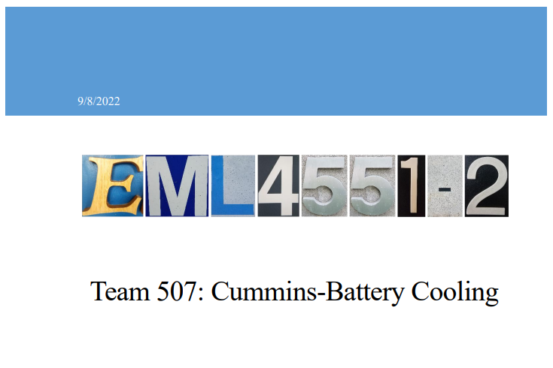

Appendices

Appendix C: Target Catalog

Function | Target Description | Metric Description
Cool Battery | <40 [°C] | Temperature
Heat Battery | >20 [°C] | Temperature
Avoid puncture | 20 [N] | Force
Withstand thermal cycling | 2000 Cycles | Durability
Minimize weight | 1.5 [kg] | Weight
Minimize energy loss due to pressure losses | 1 [kpa] | Pressure
Accommodates pouch Swelling | 10% of cell volume [m^3] | Size
Minimize total cost of ownership | $100 | Cost
Method is resistant to changing weather conditions | Rust and Freeze Resistant | Durability
Method adds minimal volume to the module | 340x230x50 [mm] | Size

